RNNs and Vanishing Gradients

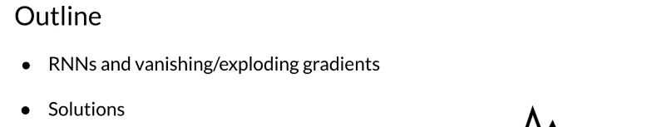

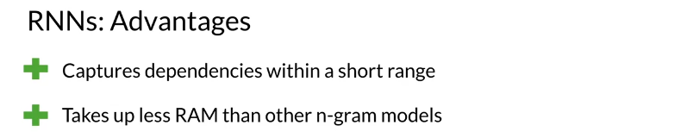

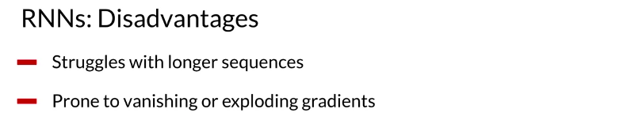

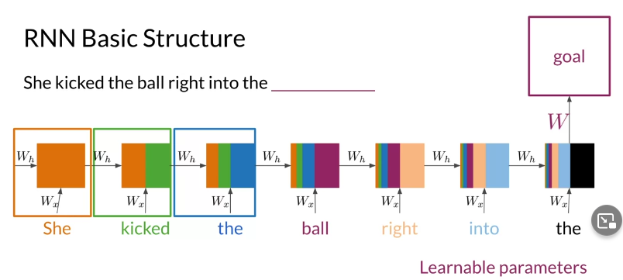

Advantages of RNNs
RNNs allow us to capture dependancies within a short range and they take up less RAM than other n-gram models.

Disadvantages of RNNs
RNNs struggle with longer term dependencies and are very prone to vanishing or exploding gradients.
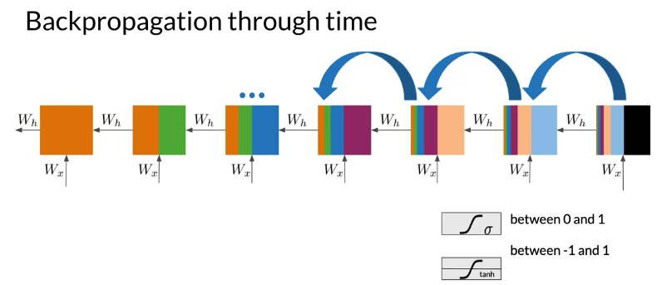
Note that as you are back-propagating through time, you end up getting the following:

Note that the sigmoid and tanh functions are bounded by 0 and 1 and -1 and 1 respectively. This eventually leads us to a problem. If you have many numbers that are less than |1|, then as you go through many layers, and you take the product of those numbers, you eventually end up getting a gradient that is very close to 0. This introduces the problem of vanishing gradients.

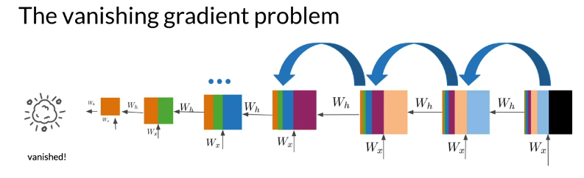

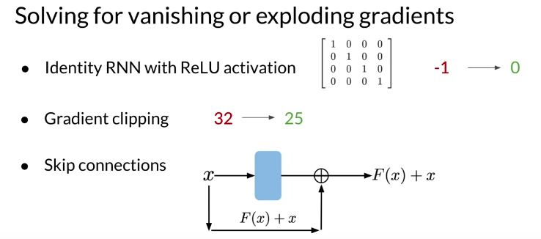

Introduction to LSTMs



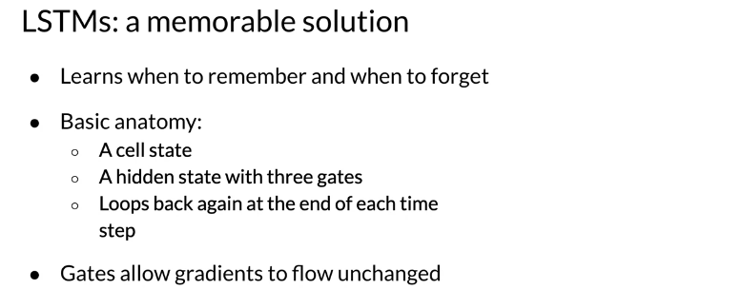

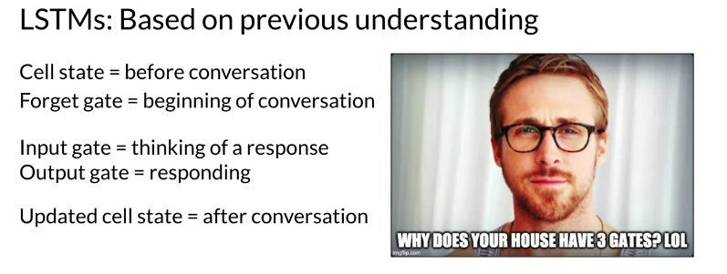

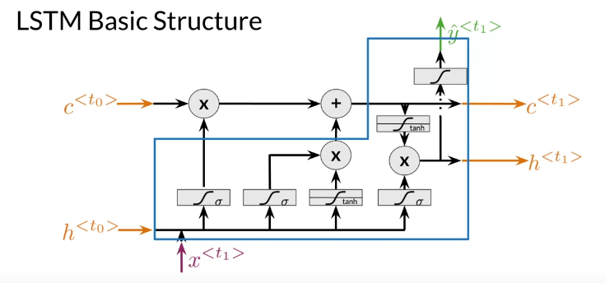

The LSTM allows your model to remember and forget certain inputs. It consists of a cell state and a hidden state with three gates. The gates allow the gradients to flow unchanged. You can think of the three gates as follows:
Input gate: tells you how much information to input at any time point.
Forget gate: tells you how much information to forget at any time point.
Output gate: tells you how much information to pass over at any time point.
There are many applications you can use LSTMs for, such as:

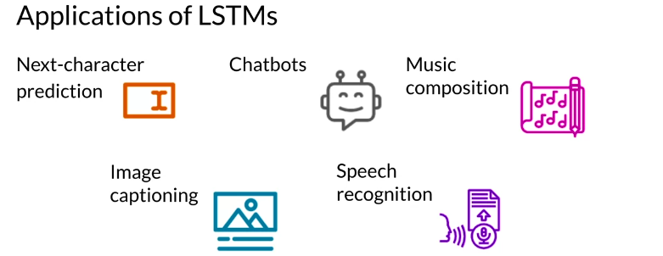

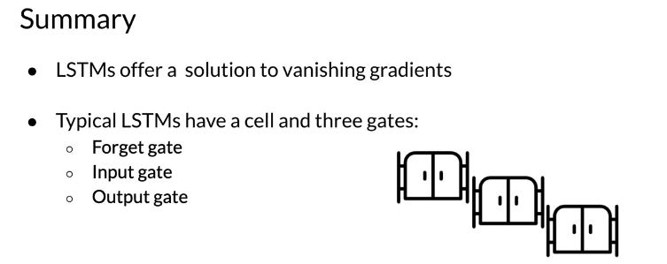

LSTM Architecture
The LSTM architecture could get complicated and don't worry about it if you do not understand it. I personally prefer looking at the equation, but I will try to give you a visualization for now and later this week we will take a look at the equations.
Note that there is the cell state and the hidden state, and then there is the output state. The forget gate is the first activation in the drawing above. It makes use of the previous hidden state h<t0​> and the input x<t1​>. The input gate makes use of the next two activations, the sigmoid and the tanh. Finally the output gate makes use of the last activation and the tanh right above it. This is just an overview of the architecture, we will dive into the details once we introduce the equations.
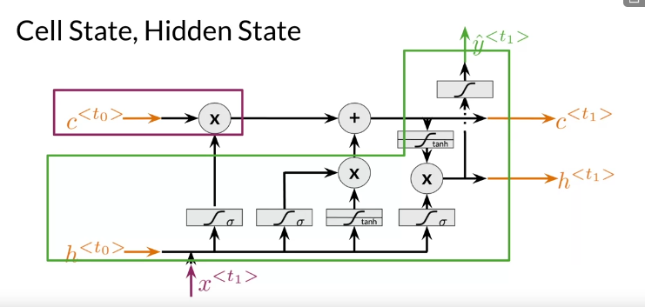

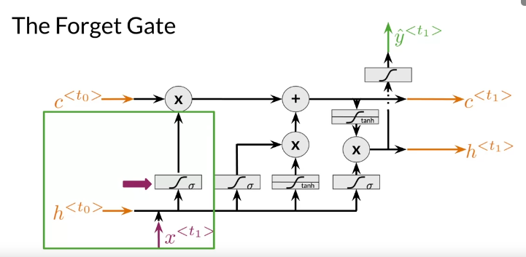
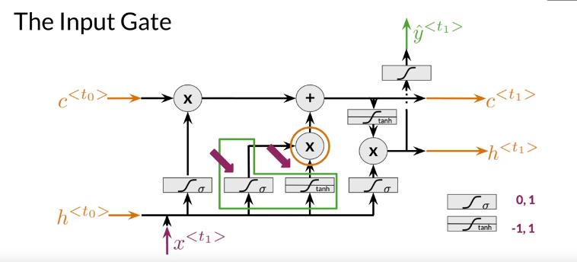

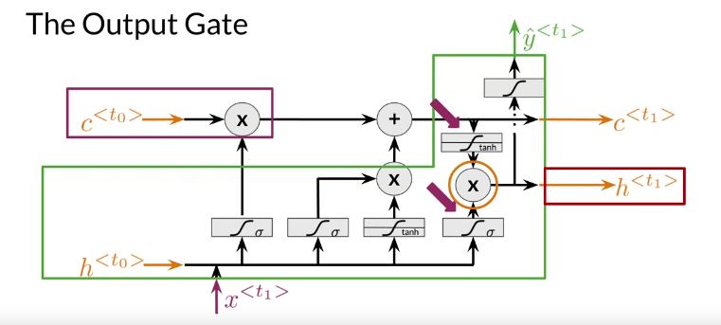
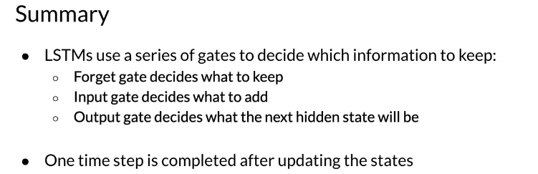

Introduction to Named Entity Recognition






Named Entity Recognition (NER) locates and extracts predefined entities from text. It allows you to find places, organizations, names, time and dates. Here is an example of the model you will be building:

NER systems are being used in search efficiency, recommendation engines, customer service, automatic trading, and many more.

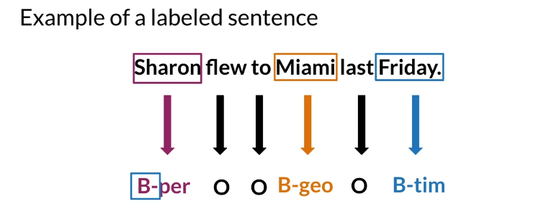


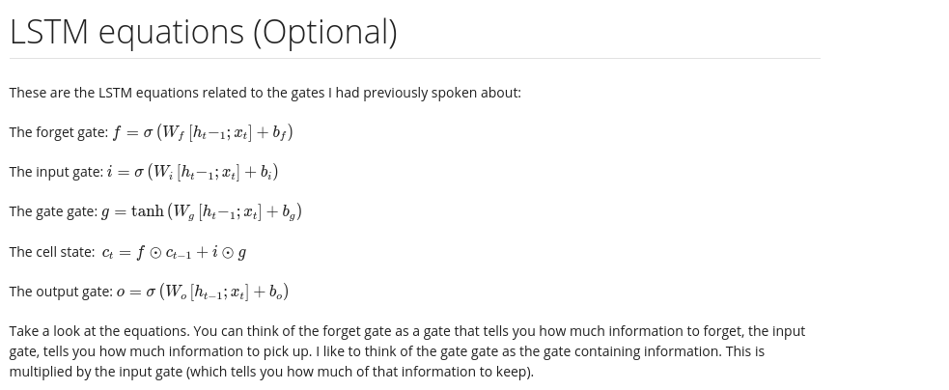

Training NERs: Data Processing


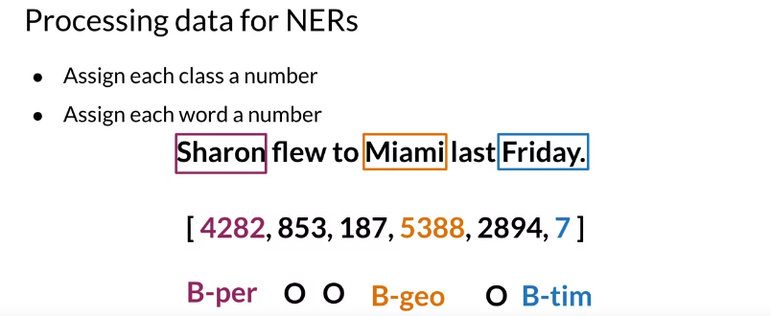

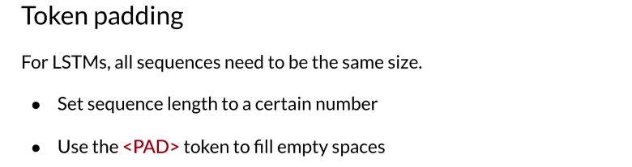
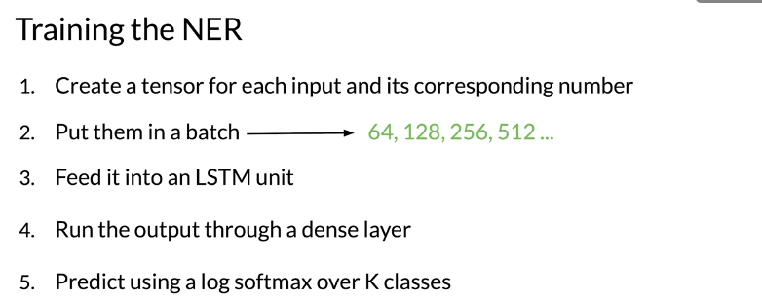

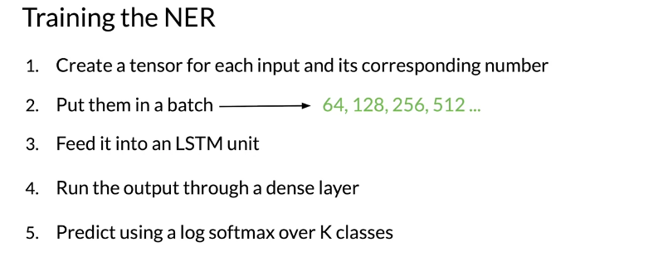
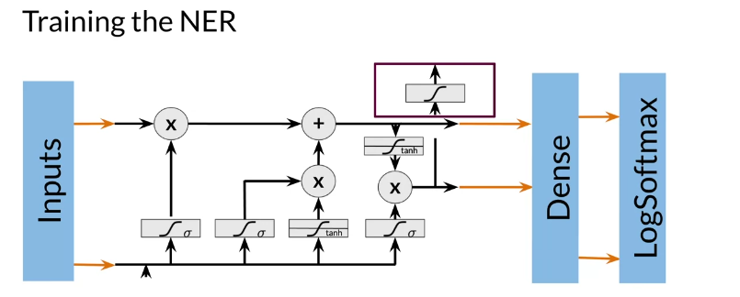

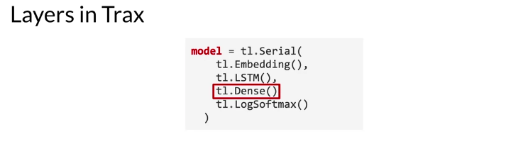
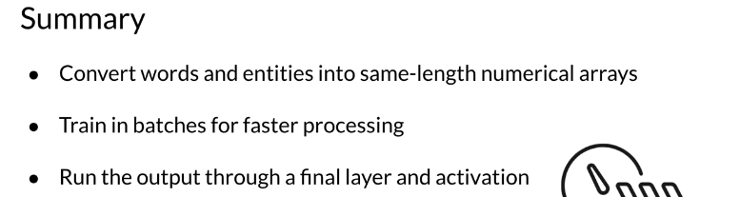

Computing Accuracy

